https://lh5.googleusercontent.com/dplghwJq6X4fhzS5H6mFhAFj9x6vI-Y8xCT8NFOTS1m1Xqxiq7nkadVUnCPhdF0ePu4loIUkqVjtvmt0NXfO2k9ohAj4vSqxuecZS-EBDoWiRGD-hgPkQa4QEs6nQaUoqsWtkTeeVLr0namIZbmEyQhttps://lh3.googleusercontent.com/BTBdPiSJjxGslQH3BeZD4BaoJZ39HCgQmAhUsT_pMmuCBkQpXF4Oufxkc29xElrbY7UOC_t-XYD8wCe8-xr0WMFCu3DhySoqaYXxkDd4zDvRd6uFglNfbvwNH7fYiWW7sNqHblYmu1wrAZV9wwFdXA

**GHARDA FOUNDATION**

**GHARDA INSTITUTE OF TECHNOLOGY, LAVEL**

Department of Computer Engineering

**Evaluation Sheet**

Class: TE-Computer Engineering Sem: VI Subject: **Artificial Intelligence Lab(CSL604)**

Experiment No: 8

Title of Experiment: Study the implementation of logical programs using PROLOG.

Name of Student: Niraj Nitin Surve Roll No: 68

Date of Performance: 01/03/2023

|  |  |  |  |
| --- | --- | --- | --- |
| Sr. No. | Evaluation Criteria | Max Marks | Marks Obtained |
| 1 | Practical Performance | 8 |  |
| 2 | Oral | 5 |  |
| 3 | Timely Submission | 2 |  |
|  | Total | 15 |  |

                   Signature of Subject Teacher

     (Prof. M. A. Khandke)

1. **Program to perform Arithmetic Operations –**

add(X, Y, Z) :- Z is X + Y.

subtract(X, Y, Z) :- Z is X - Y.

multiply(X, Y, Z) :- Z is X * Y.

divide(X, Y, Z) :- Z is X / Y.

**Output –**



1. **Program to check the number is even, odd or prime –**

is_even(X) :-

X mod 2 =:= 0.

is_odd(X) :-

X mod 2 =:= 1.

is_prime(X) :-

X > 1,

Upper is floor(sqrt(X)),

\+ (between(2, Upper, Y), X mod Y =:= 0).

**Output –**

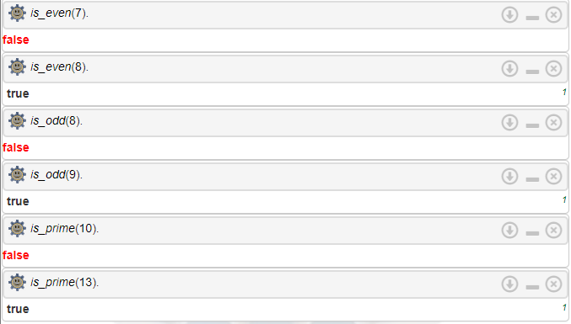

1. **Program to calculate factorial of a number –**

factorial(0, 1).

factorial(N, Result) :-

N > 0,

Prev is N - 1,

factorial(Prev, PrevResult),

Result is N * PrevResult.

**Output –**



1. **Program to find the greatest among three numbers –**

greatest(X, Y, Z, G) :-

X >= Y, X >= Z,

G is X.

greatest(X, Y, Z, G) :-

Y >= X, Y >= Z,

G is Y.

greatest(_, _, Z, G) :-

G is Z.

**Output –**



1. **Program to solve the problem of Tower Of Honoi (TOH) –**

move(1,X,Y,_) :-

write('Move top disk from '), write(X), write(' to '), write(Y), nl.

move(N,X,Y,Z) :-

N>1,

M is N-1,

move(M,X,Z,Y),

move(1,X,Y,_),

move(M,Z,Y,X).

**Output –**

